Software Requirements Specification
for
Covid-19 Application
Version 1.2.0 approved
Prepared by Enxhi Tabaku
Canadian Institute of Technology
16/06/2020
Table of Contents
1. Introduction 1
1.1 Purpose 1
1.2 Product Scope 1
1.3 Intended Audience and Reading Suggestions 1
1.4 References 2
1.5 Definitions, Acronyms and Abbreviations 2
2. Overall Description 3
2.1 Product Perspective 3
2.2 Product Functions 3
2.3 User Characteristics 4
2.4 Operating Environment 4
3. Logical Database Requirements 5
4. Functions 6
4.1 Accounts System 6
4.2 User Data 7
5. Software Systems Attributes 8
6. UML Diagrams 9
6.1 UML Activity Diagrams 9

Revision History
Name | Date | Description of Version | Version
Enxhi Tabaku | 17/04/2020 | Initial Draft | 1.0.0
Enxhi Tabaku | 25/04/2020 | Draft | 1.1.0
Enxhi Tabaku | 16/06/2020 | Final Draft | 1.2.0

Introduction

Purpose
The purpose of this Systems Requirements Specifications document (henceforth referred to as SRS) is to provide the guidelines necessary to design and implement software that fulfills all the requirements given.
In the case of the Covid-19 Application, this document will contain enough information so that in the event that the current team is not able to complete the software, a future team can use this document and only this document to create another version of the software that still fulfills all the requirements.
This SRS will be entirely design-independent, focusing only the end requirements that the final software must achieve. Furthermore, this document can be used by clients and stakeholders as a representation of their requirements for the software. Fulfilling all the requirements of the SRS will be in essence fulfilling the contract with the client.

Product Scope
This SRS will cover the software Covid-19 Application. This name is simply a developmental project name and in no ways reflects the final marketable name for the product.

Covid-19 Application will be a tool to help the users have a general idea of the chances they have of being sick with Covid-19, based on their symptoms. These users can be anyone at any age, who encounter illness symptoms and have difficulty knowing whether they have a common cold or it’s COVID-19.

Covid-19 Application will provide the most common symptoms of different illnesses in order to let the users find their symptoms, and then based on the users choice the application will calculate the risk rate of being with Covid-19.

Covid-19 Application will provide a statistical history of user symptoms and risk probability.

The ultimate goal of the software will be is to improve the ability of the users to determine whether or not their symptoms are related with the pandemic virus COVID-19.

We will have a database server supporting major cities around Albania as well as thousands of users. Above all, we hope to provide a comfortable user experience along with the best pricing available.

Intended Audience and Reading Suggestions
Following table captures the list of stockholders this doc is intended for

Stockholder Role | Notes
User | The one who will use the application
System Administrator | The one who administrate the files

References
- Introduction to Object-Oriented Programming With Java 5TH EDITION by C. Thomas Wu. McGraw-Hill Publishing Company,2010

- SRS Template: https://drive.google.com/file/d/1JRAEqlgQPMxINPVqZCmAsSmGQlS2Gzxs/view

- W.H.O : https://who.int

Definitions, Acronyms and Abbreviations
SRS – Systems Requirements Software, this document which outlines the requirements that the software must fulfill. Entirely design independent.
User – any person who uses the program.
Administrator – a person who has administrative access to the file.
GUI – graphical user interface.
Main Page – the initial menu to allow users to register by creating new accounts or to login if they have a valid login.
UML – Unified Modeling Language. Refer to http://www.uml.org/
OS – operating system

Overall Description

Product Perspective
The Covid-19 Application is independent and self-contained. An integrated data base will ensure the storage and the retrieval of the user related information and the required data. It will be the only product on the market that gives real time statistics for the risk of being infected with COVID-19. There are other kinds of software for COVID-19 designed to give a variety of real time information about the pandemic spread across the world. Even though they cover a wide range of interests, none of them are specifically designed for users who want to know their health status. The project can be easily implemented under various situation. We can add new features as and when we require making reusability possible.

Product Functions
- Sign Up – The user must register once in order to get access to the application; Name,Surname,Email,ZIP Code and Password are the required fields.
- Log-in – A registered user has to enter his/her unique email address and password in order access the application.
- Exit – User exits the program.
- Add Symptoms – User can tick their symptoms.
- Submit – User can submit their symptoms
- Patient Report - User can check their symptoms history and risk probability average.
- Notice Board – User can check the total number of infected users, the infected users in his/her area and the number of infected users in the potential infected city.

The following image shows the different functions described above and their relationships:
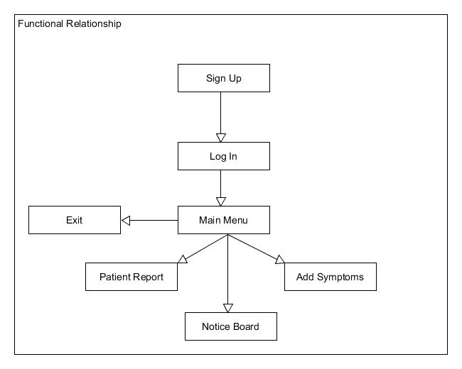

Figure 2.2.1: The different functions and their relationships

User Characteristics
- Type of users:
- Any user who feel sick
- Technical expertise:
- All users needs to have minimal technical expertise (need to know how to use the mouse and keyboard)

Operating Environment
This section describes the expected performance requirements. This is an estimation of the system, and all the numerical values may vary depends on how large the final application is.

- The system shall be loaded and functioning within 15 seconds 95% of the time after starting the application.
- Each account shall be stored and activated within 5 seconds after creation.
- The system shall support only one terminal.
- The system shall support only one simultaneous user on each machine; however, it shall support multiple users to create personal accounts and access the system on the same machine at different times.
- The system shall run on Windows (Windows 98 and above) machines with at least 10 MB of memory .

Logical Database Requirements

File Format
The system must store all the user account information as well as the symptoms records. All the user data shall be stored in a relational database, and all the symptoms will be stored locally intext-based flat files. For each user account, the unique ID, name, surname, ZIP code and Password shall be stored in one each row of the database table(users) with the ID value as a primary key. Furthermore, there shall be a file which contains every submitted symptoms result for a all the users. Each attribute shall be delimited by a colon, and all the entries shall be sorted in default order. A symptoms report file shall contain the following attributes: session ID, symptoms, and risk of COVID-19 probability. Another database table(noticeboard) shall be created to store the Zip (primary key) and case number which will be incremented by one each time the average probability for COVID-19 exceed the 75%value. In base of the user symptoms input, the Notice Board file will be updated with the latest user risk average.

Here is an example which shows how the data shall be stored and presented int Text Files

Patient_Report.txt
Format: ID,Symptom1,Symptom2,Symptom3… , RiskRate

123,Soreness,Breathing Difficulty,41%
671,Temperature,Sore Throat,Amnesia,32%

Here is an example which shows how data shall be stored and presented in Database

Users Table
ID | NAME | Surname | ZIP | Password
123 | Enxhi | Tabaku | 1000 | enxhiT123$

Noticeboard Table
ZIP | Cases
1000 | 1
9000 | 5
4500 | 0

Accessibility And Security
Only the user who has access to a certain account can access the symptoms report file and derive from it only the symptoms that match his ID.
None of the users has access to modify any of the data files.

Functions
This section explains all functional requirements from a developer’s point of view. It is categorized by subsystems.

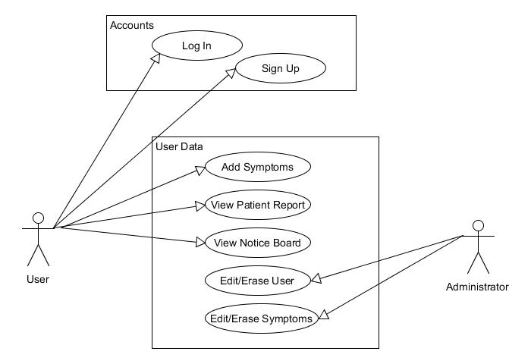

Accounts System
Log In
Description | The system should allow users to login to their account to continue with their saved progress
Sequence of Operations | - User must type in Email Add in the corresponding text field  - User Must type in Password in the corresponding password field  - User must click on the Login button
Validity Checks | User must login with the correct Credentials
Input | Registered user email, password and select “LOGIN”
Output | If “LOGIN” is selected, then verify and continue to MainMenu
Error Handling | If user credentials are incorrect, then display an error message

Sign Up
Description | The system should allow users to register an account
Sequence of Operations | 1.User fill the required form  2.User click Sign Up button, the system checks the user inputs, if no errors the user is added to the database.
Validity Checks | All user fields are filled out for account creation
Input | Fill out the following fields: name,surname, ZIP code, Password
Output | Display either a success or failure message depending on if the registration was successful or not.
Error Handling | If certain fields are not filled out properly or not filled out at all, then print out the error message and tell the user to try again.

User Data
Add Symptoms

Description | The system should allow users to tick more than one of the listed symptoms
Sequence of Operations | 1.User tick/untick symptoms  2.User click Submit, the system add the symptoms with the corresponding ID to the file.
Validity Checks | Check it at least one symptom is ticked for calculating risk percentage, and writing to file.
Input | Click on the listed symptoms.
Output | Display either a success or failure message depending on the input. The success message comes with the calculated risk percentage value.
Error Handling | If no symptoms ticked, then print out the error message and tell the user to try again.

Notice Board
Description | The system may allow the user to view the Notice Board
Sequence of Operations | 1. The user clicks on the Notice Board button  2. The system shows the number of :  a)infected users in his/her are  b)infected users in total  c)infected users in the potential infected city
Validity Checks | Check if the user is logged in and has added symptoms
Input | User clicks on the Notice Board button
Output | Latest Notice about Covid-19
Error Handling | None

Patient Report
Description | The system may allow the user to view their symptoms history.
Sequence of Operations | 1. The user clicks on the View History button  2. The system shows the user history on screen
Validity Checks | Check if the user is logged in
Input | User clicks on the View History button
Output | User history and average risk percentage value is displayed
Error Handling | None

Software Systems Attributes

Reliability
The system will not crash on invalid data files or input files.Monitoring. The data files will be stored on a nonvolatile storage device such as a hard drive, so that the data files can be retained when the system is shut off. The will check the validity of the user files when they are loaded. If there is an error the system will ask the user to make a new account. If there is a fatal error the system shuts down without crashing the computer it is running on.

Availability
The system will only run infrequently. The system will allow the user to restart the application after a crash. All data beyond the last save point will be lost. The user will be able to load his or her data file after the system has been restarted and continue using the system. The system will have an average run time of 5-10 min per session depending on the user, although the user may use the system longer.

Security
The system will use the computer’s default operating system security. The system will not use any of its own security features since the software is not web-based and it is not going to be run over a network. The system will be contained on one computer. The data files will not be encrypted since the data stored in these files should be easily modifiable and readable in case the system is used for research. The system checks the validity of the data files when it is running and if the data is invalid the system outputs an error to the user. The system will not keep log files of the User’s usage.

Portability
The product will be able to run Windows. The software will be written in NetBeans.We will write all the software using Java. The system’s data files will be portable for Windows. The user will have to install Java Runtime Environment (JRE) separately if it is not already installed on the computer they are running the system Or if they already have it, to run the program they need to update the JRE on Version 8.0 on the computer.

UML Diagrams
In the following diagram is described the dynamic aspect of the system.

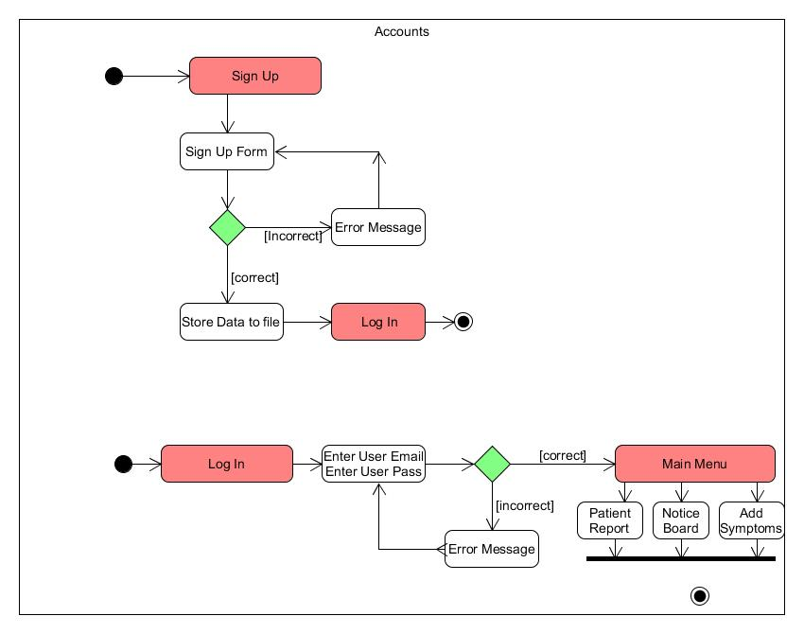
UML Activity Diagrams

